TURN-ROW CREDIBILITY WORKSHOP II
Holiday Inn, 115 Cypress Centre Blvd, Vicksburg, MS
LA/MS MAV CDN Working Ag Lands Working Group

October 9-10, 2019

Date: October 9, 2019

9:00 -10:00 a.m. Registration

10:00 a.m. Welcome and Workshop Objectives - David Breithaupt, Chair, LA/MS MAV CDN

10:10 a.m. Conservation Delivery Network Highlight - Steve Brock, Partnership Coor., LMVJV

10:15 a.m. Annual Farm Planning and Decisions - Jon Allison, Tallahatchie County Producer

11:00 a.m. On-Farm Business Decisions and the Factors That Influence Them - Dean Bell,
Farm Manager & Agronomist, Southern Agronomic Resources

11:45 a.m. Lunch - Sponsored by Lower Delta Partnership and Walton Family Foundation

12:45 a.m. Conservation Planning - Terry Johnston

1:15 p.m. Irrigation Water and Management (IWM) - Paul Rodrigue, Supervisory Irrigation Engineer, MS NRCS

2:00 p.m. Wetland Policy/What You Need to Know - Kevin Nelms, MS NRCS

2:45 p.m. Open Floor - Panel Discussion
Moderator: David Breithaupt
Panel Members: Jon Allison, Producer
Dean Bell, Farm Management Consultant
Terry Johnston, LA NRCS
Paul Rodrigue, MS NRCS
Kevin Nelms, MS NRCS
4:00 p.m. Wrap-Up and Information on Day Two Field Tour

5:30 p.m. Gather for evening meal - The Gumbo Pot Restaurant (3401 Halls Ferry Rd)
Cost of the evening meal covered by LDP & WFF*
*(any alcoholic beverages must be paid for by individual participants)

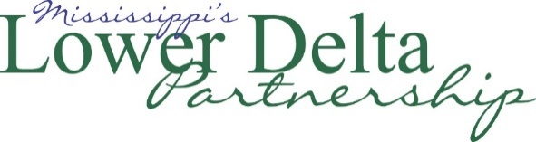

Day Two Workshop Field Tour

Date: October 10, 2019

Field Tour: Farming Practices, IWM and Conservation Planning on Working Ag Lands

7:45 a.m. - Gather at Holiday Inn Parking Lot

8:00 a.m. - Depart for Field Trip

Stop 1 - Conventional farm equipment
Stop 2 - Conventional tillage and irrigation practices
Lunch - Irrigation technology trailer
(Sponsored by LDP & WFF)
Stop 3 - Irrigation well and water management basics
Stop 4 - Irrigation Water Management practices
Stop 5 - Farm planning alternatives - considering irrigation planning, farm business objectives, & wetland policy with landowner perspectives
3:30 p.m.- Adjourn

